Magento Training Task List

Task 1:

Custom Order ID Task

1. Create one new column field in sales order table,

2. Create the one Id with random key

3. Insert the value into table when place the order

4. Display the corresponding field in the admin order grid.

5. Also, that field should have sorting and filtering.

Solution Followed

* Using db schema created added order random column in sales_order table and sales_order_grid table.
* In di.xml created virtual type for the sales order grid resource, adding a custom column named "order_random" to the grid.
* Taken event sales_order_place_after it need to generate 6-digit random number
* In observer file mentioned generate 6-digit random key and created a new method will check whether the random number already exists or not if it exists it again generate 6-digit random number it will avoid repeatation
* Used ui_component to display order_random column in magento admin grid.
* Added filter option in ui_component.

Output

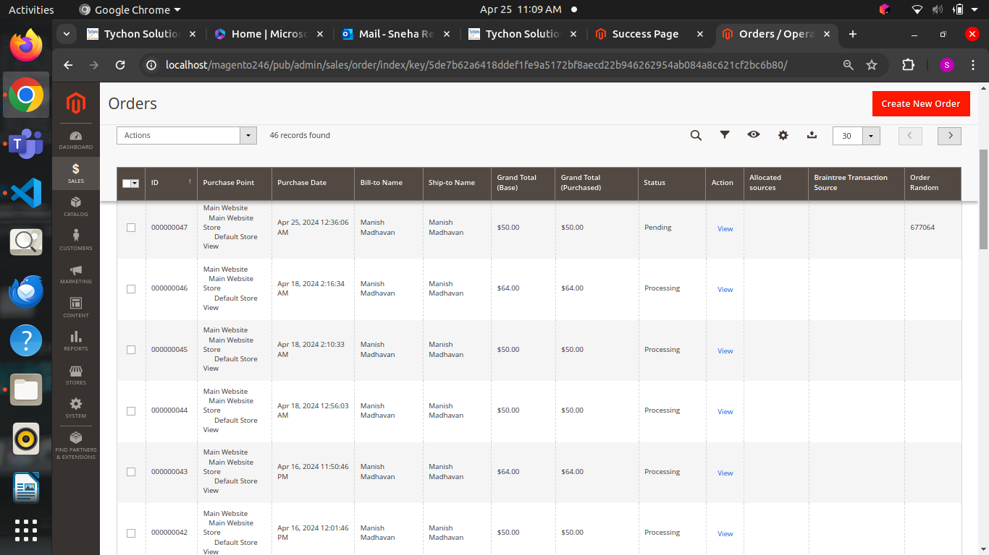

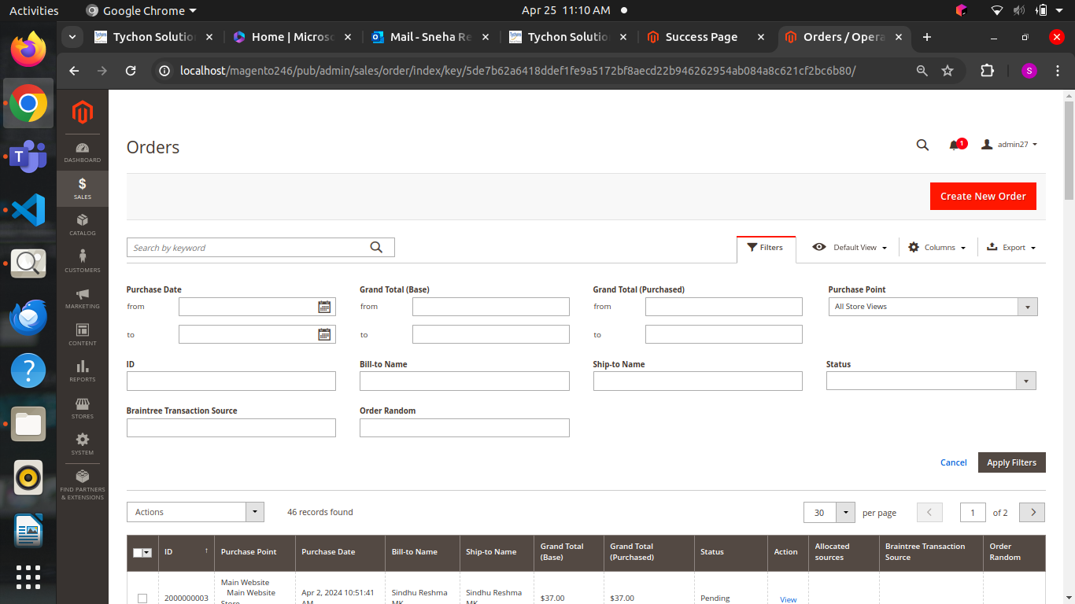

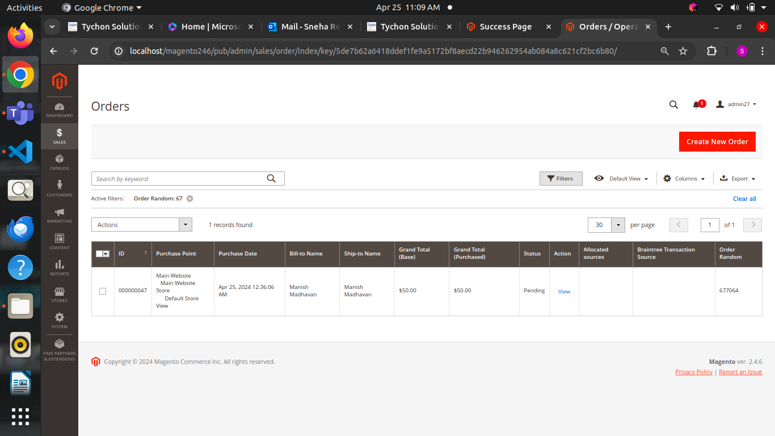

Task 2:

Using join add an order random column in admin

Task 3:

Need to display generated random number in the success page and add i18n concept

Completed task 2 and 3 in the same module

Solution followed:

* In model, collection.php file used join left and added order random column in sales order table
* Event taken sales_order_place_after
* In di.xml and override with my collection.php file
* In observer file added some procedure followed in magento task 1
* In Ui component folder orderrandom.php file retrieves the order_random value for each order in the data source and adds it to the corresponding item in the data source array.
* In layout checkout_onepage_success.xml
* Templates mentioned the order random and displayed the random number added in the database
* In Ui component added order_random column

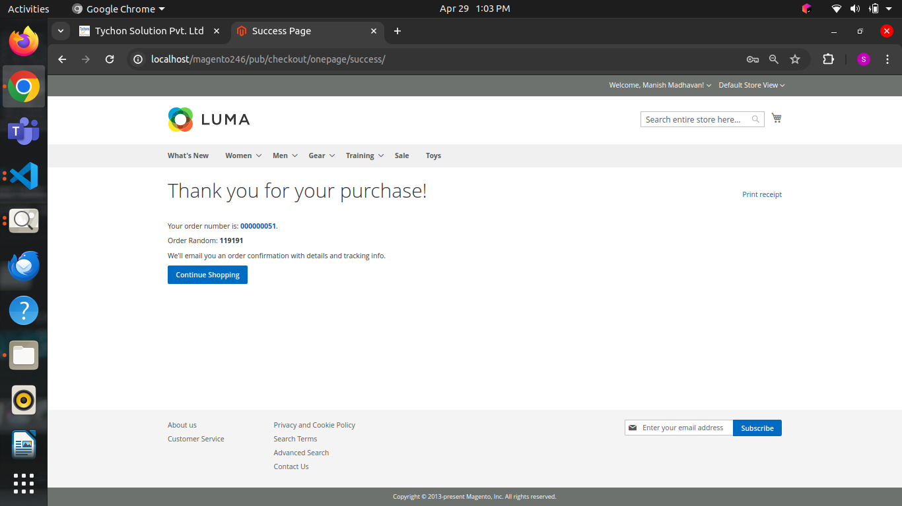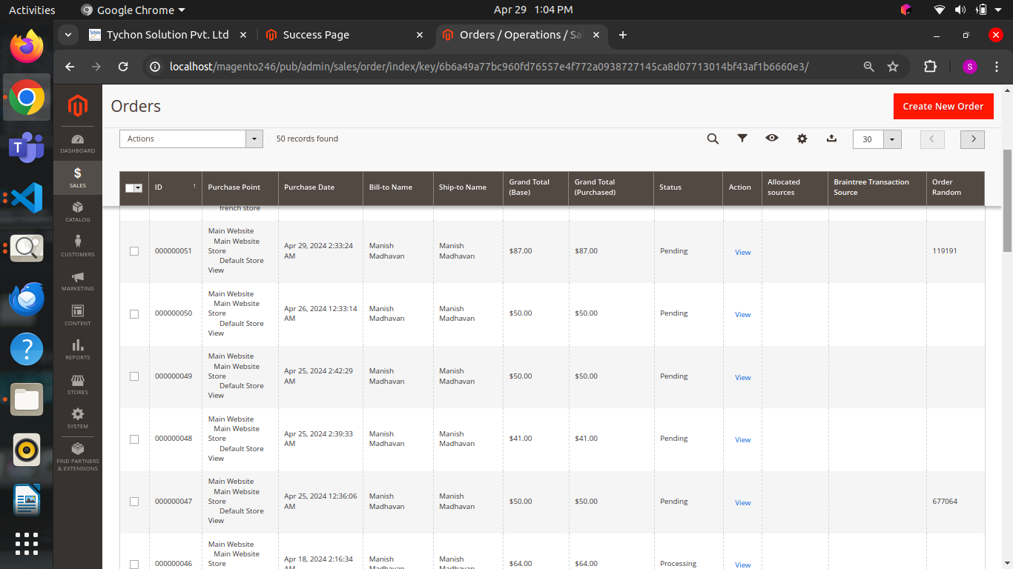

Task 4:

Magento promotions document

Solution followed:

* Analyse both catalog and cart price rule applied the features and understand the concepts and added reference screenshot for more details

Task 5:

Magento promotions related tables document

Solution followed:

* Analyse and referred 9 tables for catalog and 11 tables for cart price rule

Mentioned each table uses and work flow in the document

Task 6:

Default Payment methods and shipping methods in magento 2

Solution followed:

* In this document covered 9 payment methods in a detailed way   
  example cash on delivery, bank transfer, money order ,paypal, authorize.net and some more
* Mentioned 7 types of shipping methods in a detailed way

Example same day delivery, flat rate, free shippping, table rate ,ups,usps, fedex and some more

Task 7:

Creating the custom shipping methods.Custom shipping method only display for Canada address in front end checkout page.

Solution followed:

* As usual followed basic procedure to create a module
* In model folder created carrier file
* Defines a custom shipping carrier named Simple shipping in Magento, implementing methods to calculate and return shipping rates based on configuration settings.
* It restricts shipping availability to the destination country "CA" (Canada) and provides a price for the shipping method based on the configured price in the module settings.

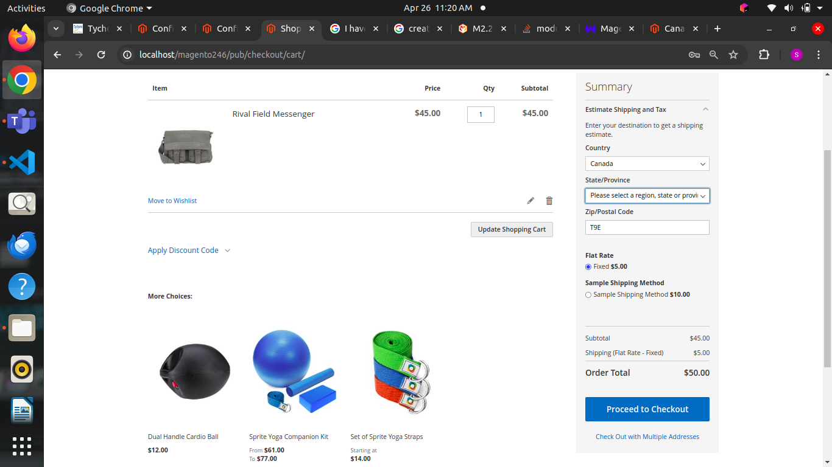

Task 8:

Overview of payment methods and modules document.

Solution followed:

* Magento 2 provides various core payment method modules, including Magento**_**Payment for basic functionalities, Magento**_**OfflinePayments for offline transactions, and integrations with gateways like Magento**_**Braintree and Magento**_**Paypal.
* Developers can create custom payment methods by structuring the module, implementing payment logic, integrating with gateways, and managing configurations through system settings.
* Payment-related details for orders, such as those made with Check/Money Order, are stored in tables like sales_order, sales_order_payment, and quote_payment to track transaction information.

Task 9:

Order Flow Analysis Document

Solution followed:

* The order flow in Magento 2 begins with customers adding products to their cart and completing the checkout process, where their information is stored in related tables like quote, quote_item, and checkout_session.
* Upon placing an order, this data is transferred to the sales_order, sales_order_item, and sales_order_address tables, with inventory and payment adjustments made accordingly.
* Invoices and credit memos are generated during order fulfillment and refund processes, with various triggering events managing the lifecycle of these documents and related actions in the system.

Task 10:

Price content

1. Need to display some block content on PLP, PDP, and checkout page (Please check

the below screenshots).

2. Content should be specific to the store view (ex. French store, content in French).

3. Need to display all product types.

4. The product price will be divided by 48 and displayed within the price content.

Example Product Content,

As low as $0.67 per month over 48 month(s). please refer the below screenshot

Solution followed:

* Started with module creation logic
* Block class code retrieves and displays the current product price and quote total, both divided by a constant value (DIVIDE_VALUE), using the registry and checkout session models.
* Helper class retrieves the currency symbol for the current store, returning a specific symbol ('$US') for store ID '2' and the default currency symbol for other stores.
* I18n folder will used to translate the words when language changed by the user
* In view mentioned specific xml file to display both pdp and plp page
* Using web folder added the flexiti images and completed the task

Output

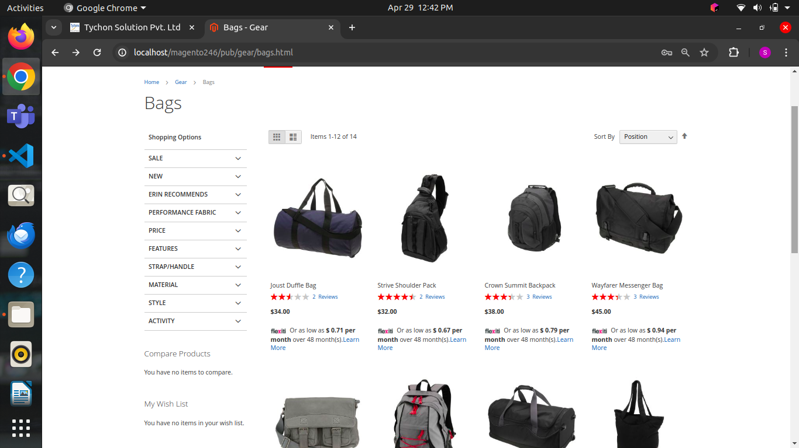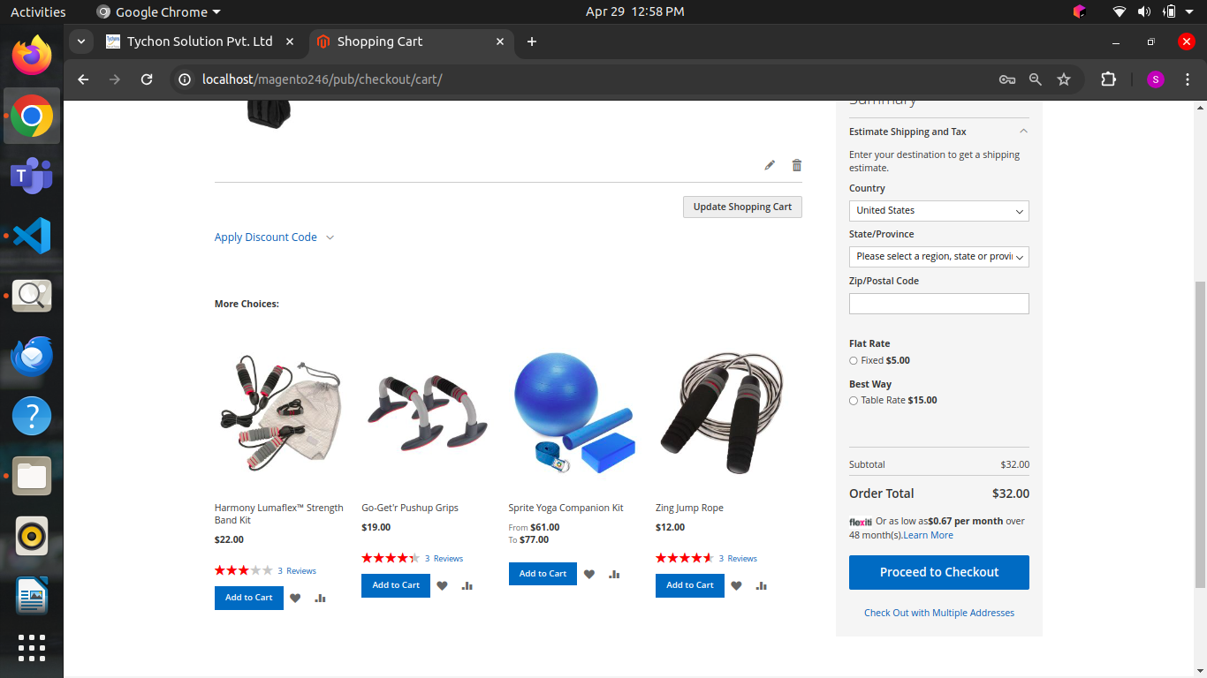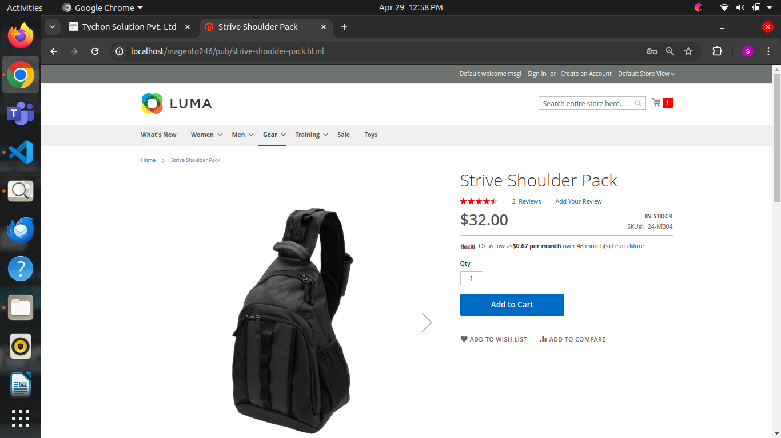

Task 11:

Difference Between Rest Api and Soap Api

Solution followed:

* Mentioned the differences between REST APIs and GraphQL in terms of querying, caching, learning curve, and performance, while also defining APIs and mentioning Magento 2's built-in API for enabling interactions with its functionalities.

Task 12:

Price content task using Api

Solution followed:

* Same as price content block task
* Api file defines a PHP interface CustomInterface in the Tychons\PriceContent\Api namespace, which declares a single method getData that takes a string parameter and returns a string, intended for a GET API operation.
* This block class Price in the Tychons\PriceContent\Block namespace manages price-related functionality by retrieving custom product data via an API, calculating the current product's price and the total quote price, and logging errors if data retrieval fails.
* Web api.xml file defines a REST API route in Magento 2, allowing anonymous users to access a POST endpoint at /V1/rest_dev/custom-api/, which maps to the getData method of the Tychons\PriceContent\Api\CustomInterface class.
* Helper file class retrieves the currency symbol for the current store in Magento 2, returning a specific symbol for store ID '2' and the standard currency symbol for other stores.
* Model folder class implements a custom API interface that retrieves a product's price by its ID, divides it by a constant value, and returns the formatted price, handling exceptions by returning zero.
* Same procedure for layout and template followed in price content block task
* This View Model class provides a method to retrieve the currency symbol using a helper class, which can be used in the cart_price.phtml template.

Output

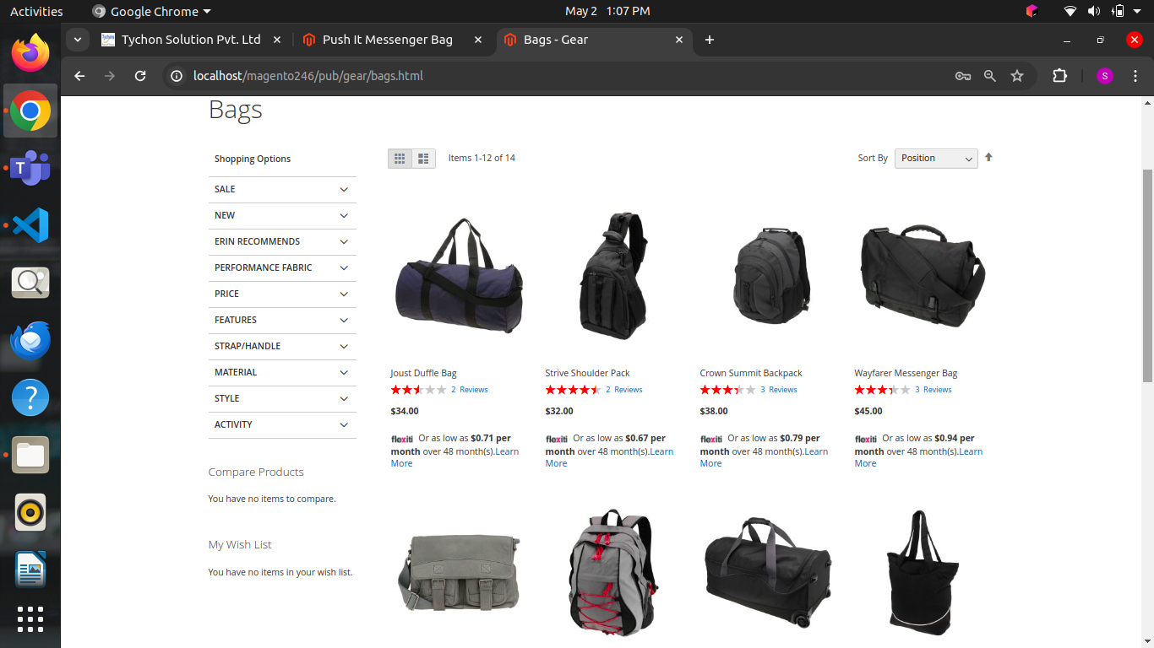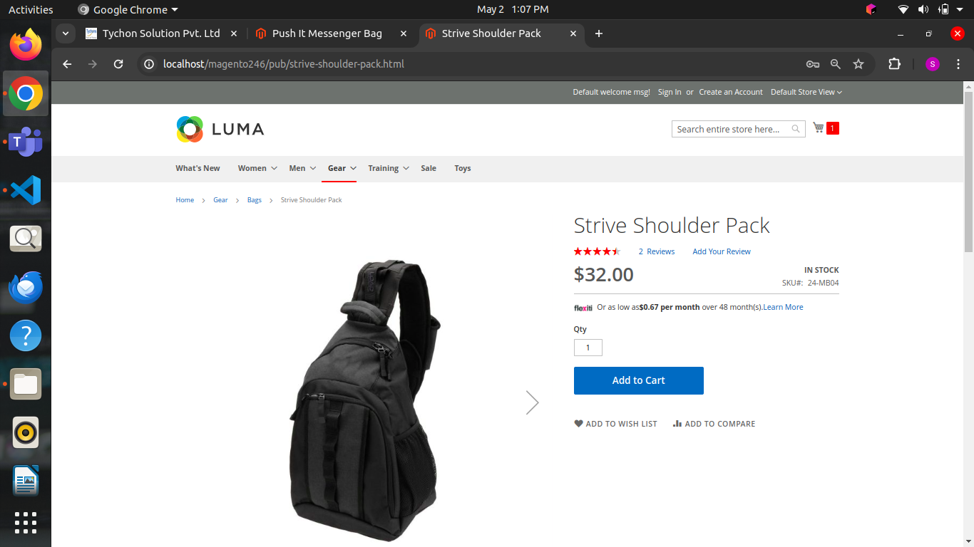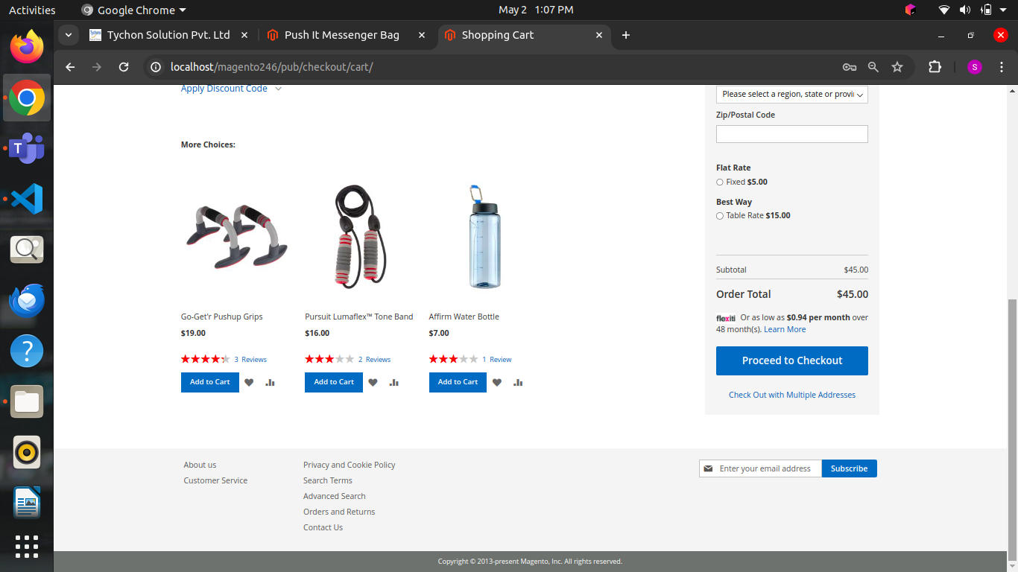

Task 13

Graphql documentation

Solution followed:

* This document provides an overview of GraphQL, detailing its advantages over RESTful APIs, its implementation in Magento 2, and examples of querying and mutating data within the platform.

Task 14

Price content task using graphql

Task 15

When we click learn more button it needs to popup and display that specific product name, sku, price and offer price

Solution followed

Completed this task 14 and 15 in the same module

* block class in Magento 2 retrieves product price data using GraphQL, manages checkout session details, and provides methods to get current product and quote prices, as well as detailed information about products in the cart.
* schema defines a query getCustomData that takes a productId as an input and returns a PriceOutput type containing a float output, with the resolver implemented in the Tychons\GraphPrice\Model\Resolver\CustomData class, which retrieves custom price data for a product.
* helper class Data in the Tychons\GraphPrice module retrieves the currency symbol for the current store, returning a specific symbol for store ID '2' and the default currency symbol for other stores.
* GraphQL resolver retrieves a product's final price by its ID, divides it by 48, and returns the result rounded to two decimal places, handling exceptions related to product retrieval.
* Then for view folder followed same procedure done in price content api task used web folder to add logo image
* When learnmore button is clicked it need to popup used js code and fetched the product details

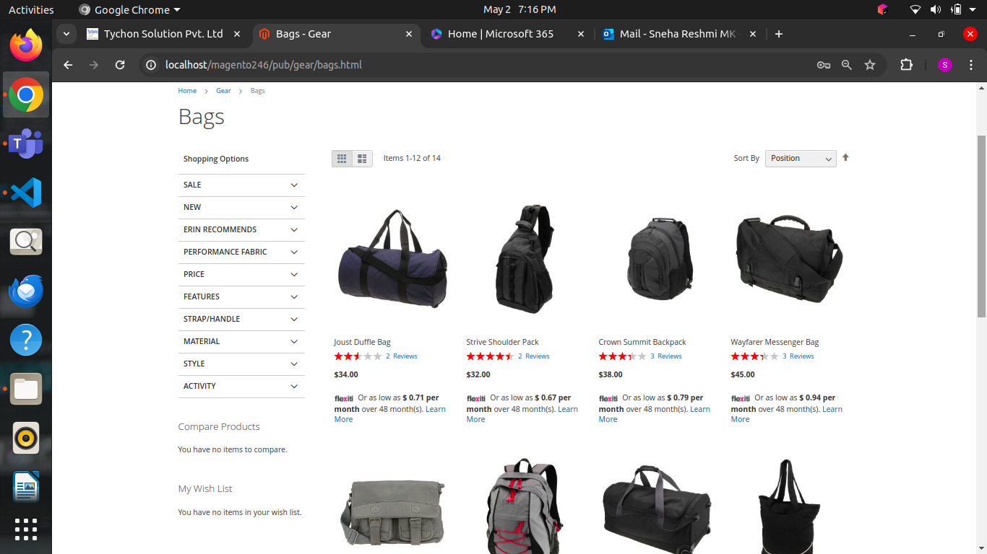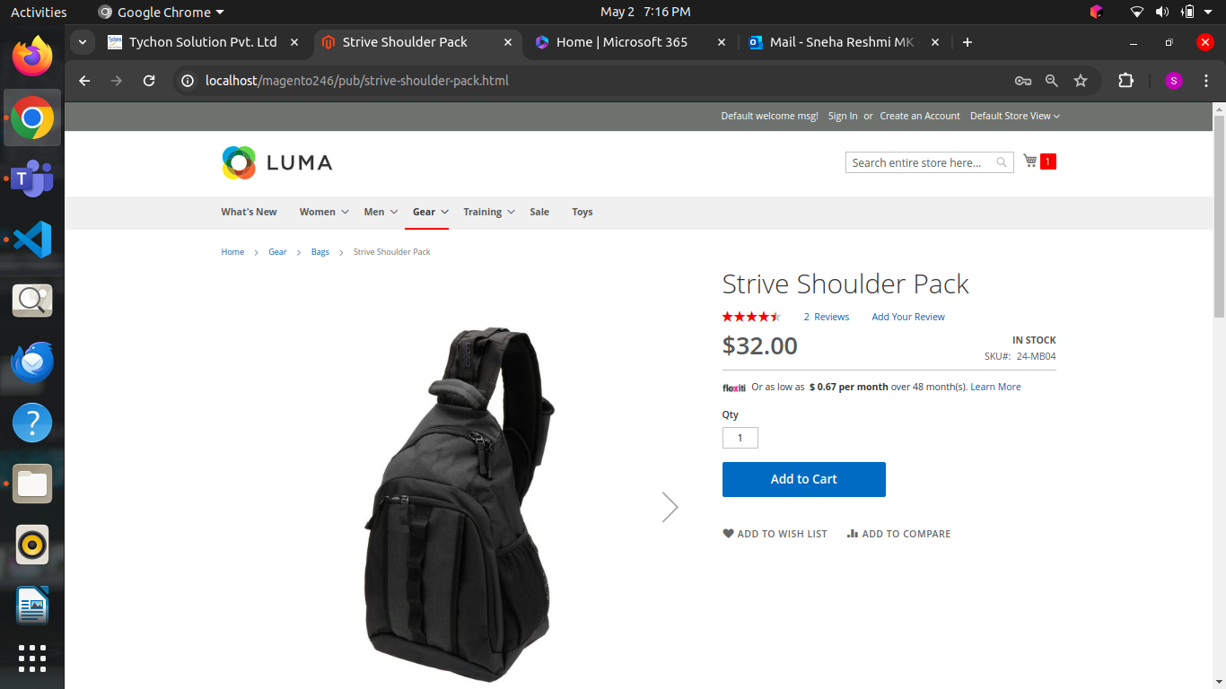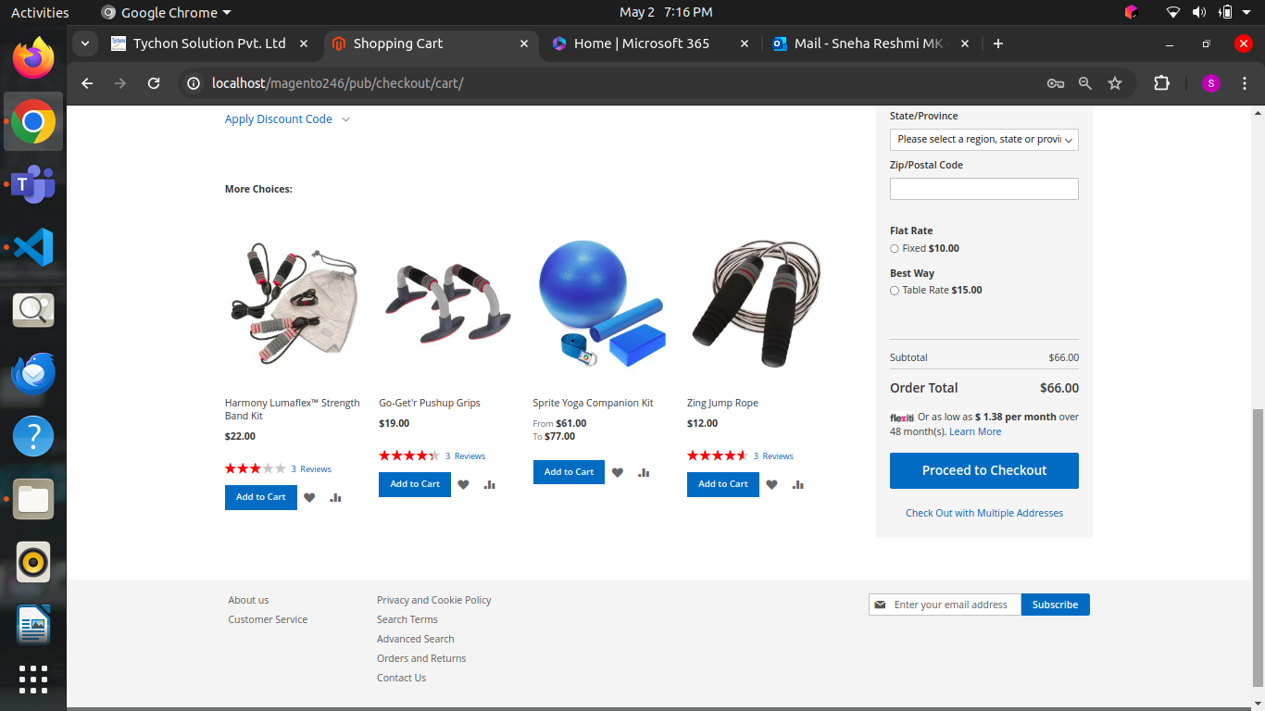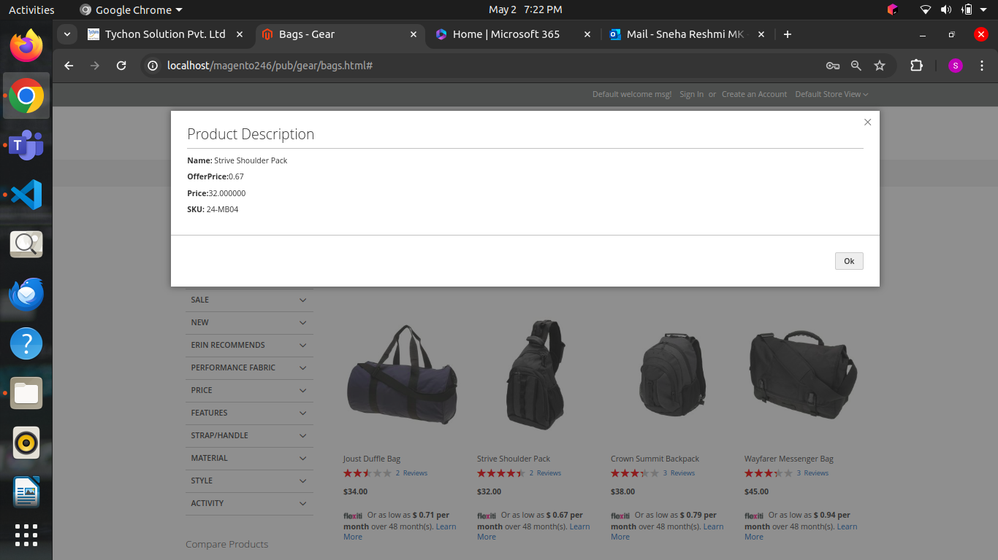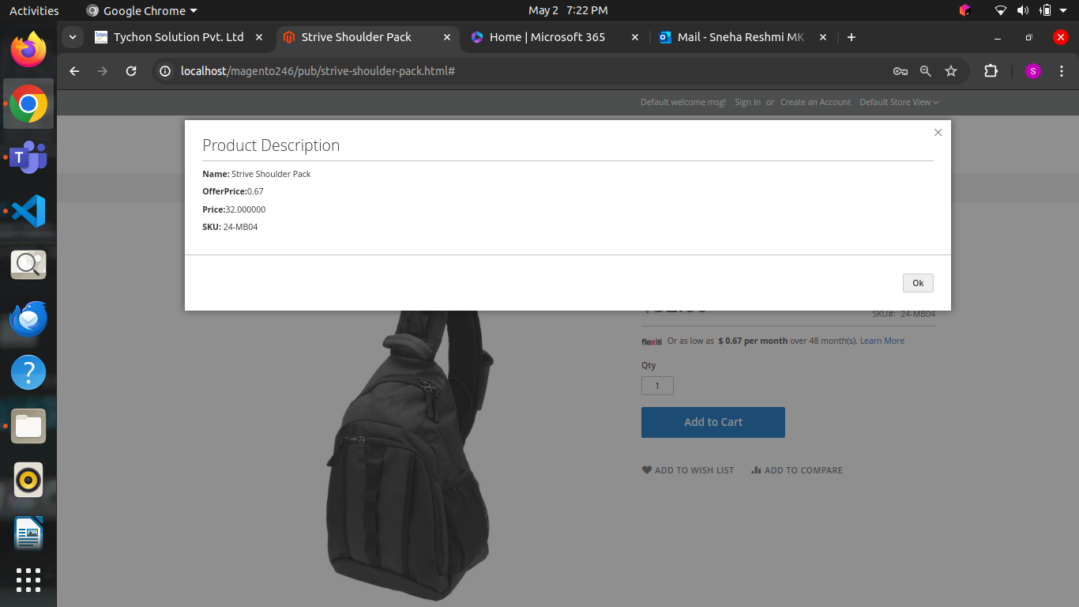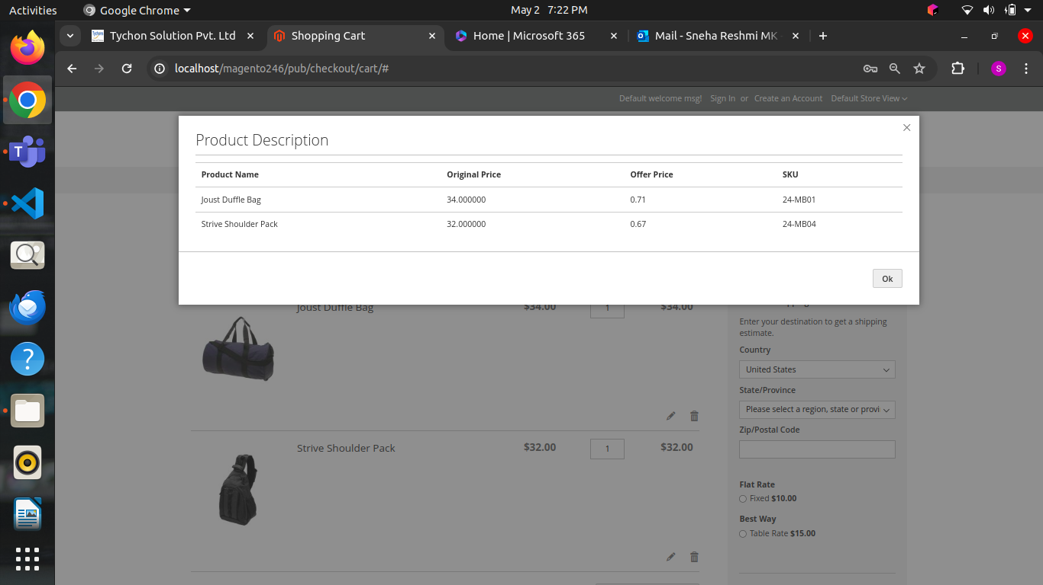

Task 16:

B2B Topics document task

Solution followed:

* This document outlines the key aspects of B2B account management, custom pricing and quoting, advanced catalog management, and customizable checkout workflows in Magento 2, highlighting their purposes, usage, benefits, and disadvantages for enhancing business relationships and sales efficiency in B2B transactions.

Task 17:

Magento versions document task

Solution followed

* In this document I have mentioned the software dependencies and notable features for Magento versions 2.4.3 through 2.4.6, highlighting improvements in performance, security, and platform compatibility. It details each version's software requirements, such as Elasticsearch, MariaDB, PHP, Redis, and RabbitMQ, alongside any known issues related to extension compatibility.
* The focus is on patch updates and the evolution of Magento's core infrastructure and security features.

Task 18 & 19:

Need to display shipping address in the sales order view page in magento admin panel

By using both graphql and Api

Completed task 18 and 19 in single module

Solution followed

* Api code defines an interface CustomerAddressInterface in the Tychons\Adminaddress\Api namespace, with a method getCustomerShippingAddress() to retrieve the shipping address for a given customer and order.
* This block file Graph retrieves customer shipping address data via a GraphQL API call using Curl, with support for order and customer details, and logs the response in Magento's admin order view.
* Model api file defines a model class CustomerAddress that retrieves the shipping address for a customer from a specific order using the OrderRepository, logging any errors encountered.
* Model resolver file defines that This CustomerShippingAddressResolver class implements a GraphQL resolver that retrieves a customer's shipping address for a specific order by using the provided customer and order IDs.
* Same as previous task used sales_order_view.xml for layout and assigned value sin the template file

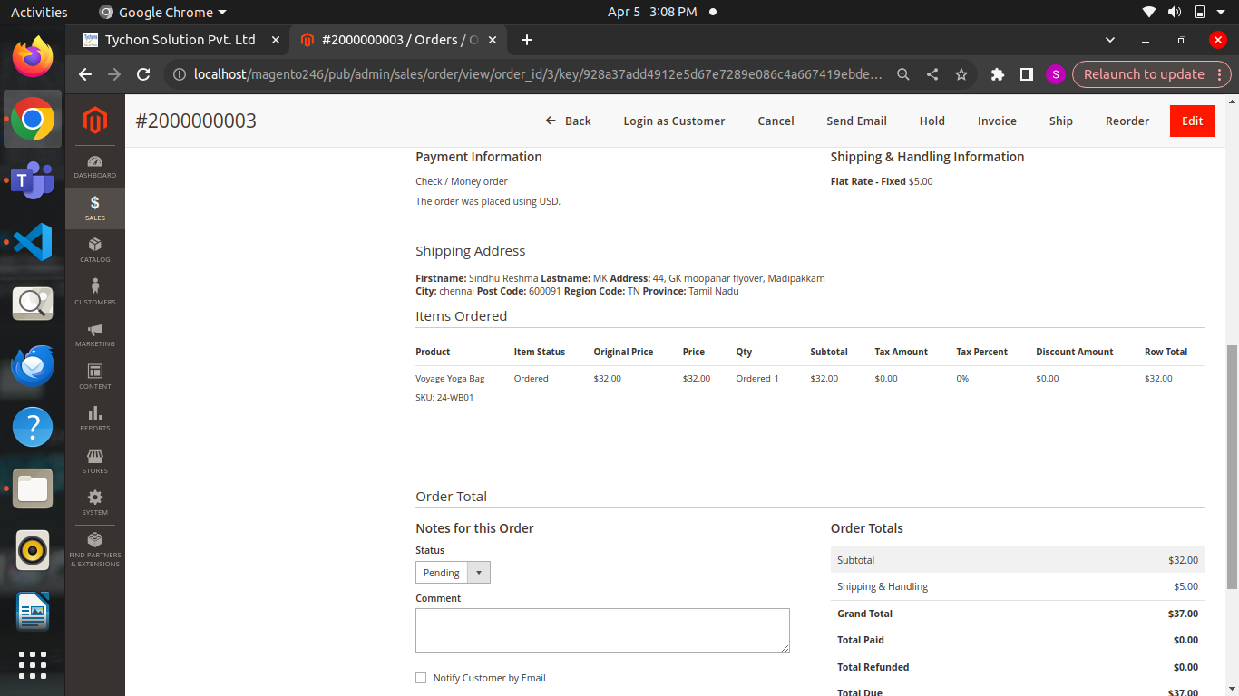

Task 20:

Cron and order status document task

Solution followed:

* In this document I mentioned how to configure and use Cron jobs in Magento 2 for automating tasks, create and manage custom order statuses in the admin panel, and how to assign a custom order status to an order when it is placed.

Task 21:

Created a simple cron and checked cron job is running successfully in logger

Created order custom order status and displayed in admin panel order details page

Solution followed:

Cron:

* class Example logs a message indicating successful execution when its execute method is called, utilizing a LoggerInterface for logging within a cron job context.
* Cron_groups.xml configures a Magento custom cron group named "custom" with specific scheduling intervals, history retention periods, and settings to use a separate process for executing cron jobs.
* Cron_tab.xml This XML defines a cron job named "Tychons_Cron" in the "custom" group, which runs the execute method of the Tychons\Crontask\Cron\Example class with a schedule of running every minute in April.

OrderStatus:

* Controller class Validate is a Magento admin controller that retrieves an order by ID, sets its state and status to "processing," saves the changes, and displays a success or error message accordingly.
* Cron class ProcessPaymentReviewOrders is a Magento cron job that runs every 30 minutes, finds orders in a specific "processing fulfillment" status older than 30 minutes, updates their state and status to "processing," and logs the process or errors.
* class AssignCustomStatus is an observer that listens for an order event and sets the order status to "processing fulfillment" when the event is triggered.
* PHP Magento plugin adds a "Validate" button to the admin order interface when an order is in the "payment_review" status, allowing administrators to validate the order through a custom URL.
* data patch adds and assigns custom order statuses ("Payment Review" and "Some Custom Status") to existing and new order states within the sales order workflow.
* "tychons_orderflow_process_payment_review_orders" in the "default" group, which runs the execute method of the Tychons\OrderFlow\Cron\ProcessPaymentReviewOrders class every 30 minutes.

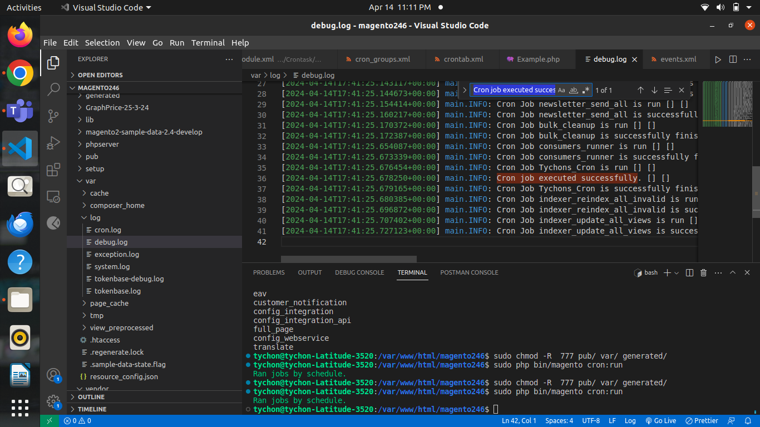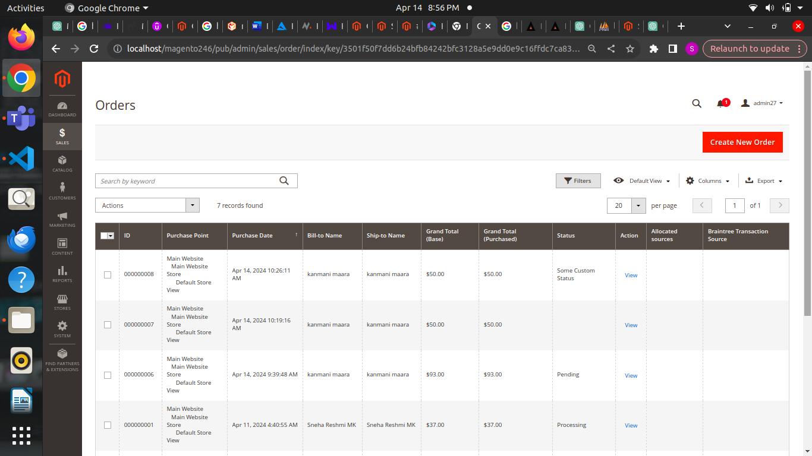

Task 22:

Magento migration tool and standalone document task

Solution Followed:

Migration tool document:

* The Magento Data Migration Tool is a command-line utility that transfers data from Magento 1 to Magento 2 while ensuring compatibility and accuracy through a structured process with best practices for a smooth migration.

Standalone document:

* This document explains standalone applications, their characteristics, benefits, and differences from client-server applications, focusing on Osquery as an example of a standalone tool for querying and monitoring system information, including installation instructions and commands.

Task 23:

Coding standard document task

Solution followed:

* This document outlines Magento 2 coding standards, their advantages and disadvantages, the role of PHPStorm as an IDE for PHP development, how it supports coding standards, and instructions for installing and setting up PHPStorm to ensure compliance with Magento 2 standards.

Task 24:

Inventory management in magento 2

Solution followed:

* This document provides an overview of inventory management features in Magento 2, detailing product stock options, stock status, quantity management, stock alerts, backorders, multi-source inventory, warehouse management, inventory tracking, handling of product bundles and configurable products, third-party integrations, and the benefits and configuration of the store pickup functionality.

Task 25:

Create a validate button in sales order view page and need to change order status when validate button is clicked (pending to processing)

Solution followed:

* controller class Validate that validates an order by setting its state and status to "processing" and then saves the changes, while providing success or error messages based on the outcome.
* cron job class ProcessPaymentReviewOrders that retrieves and processes orders with a specific status that are older than 30 minutes, updating their state and status to "processing," while logging the order IDs and any errors encountered during execution.
* code defines an observer class AssignCustomStatus in Magento 2 that listens for order events and updates the order's status to a custom fulfillment code when triggered.
* plugin class PluginBefore in Magento 2 that adds a "Validate" button to the order management interface if the order status is "payment_review," allowing admin users to validate the order when viewing it.
* the InstallData class for the Tychons_OrderFlow module in Magento 2, implementing the InstallDataInterface to add custom order statuses ("Payment Review" and "Some Custom Status") and their corresponding states during module installation.

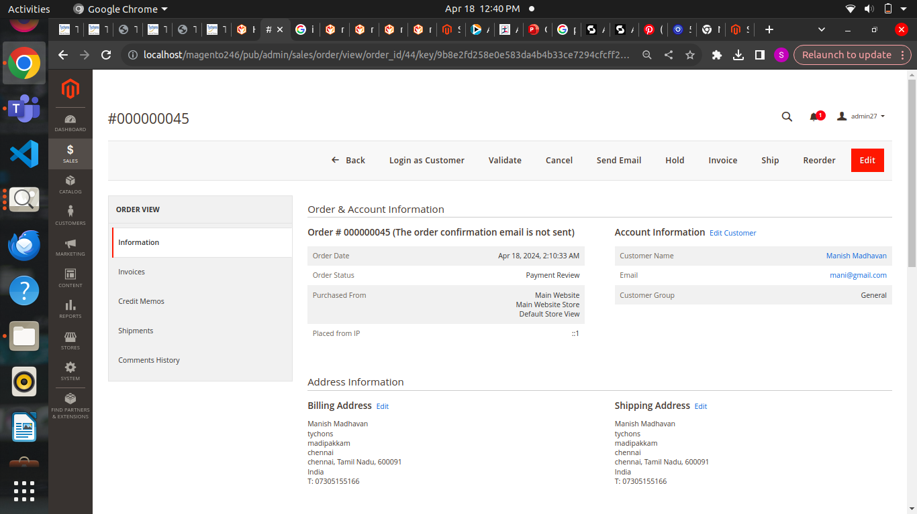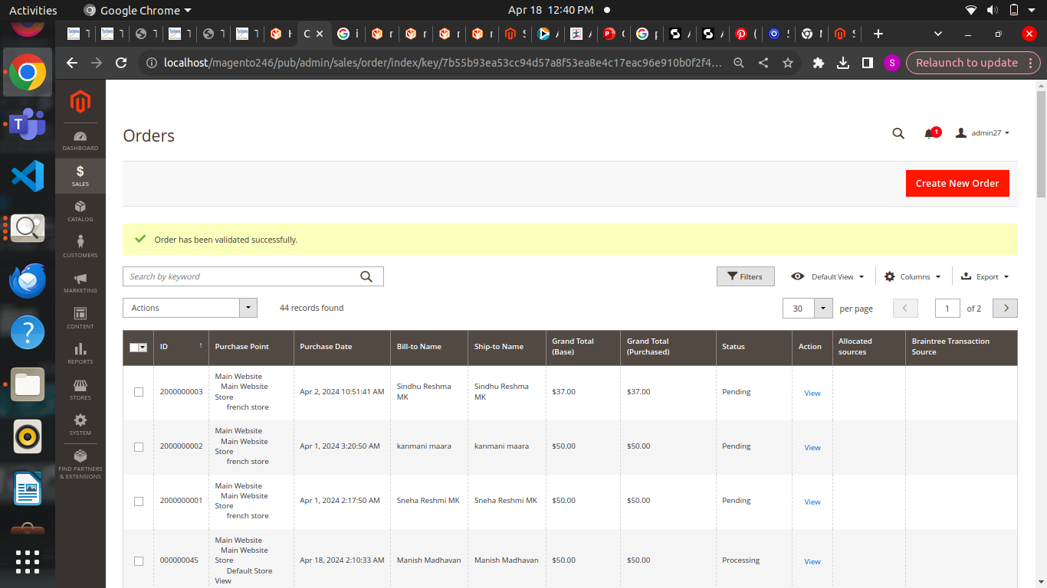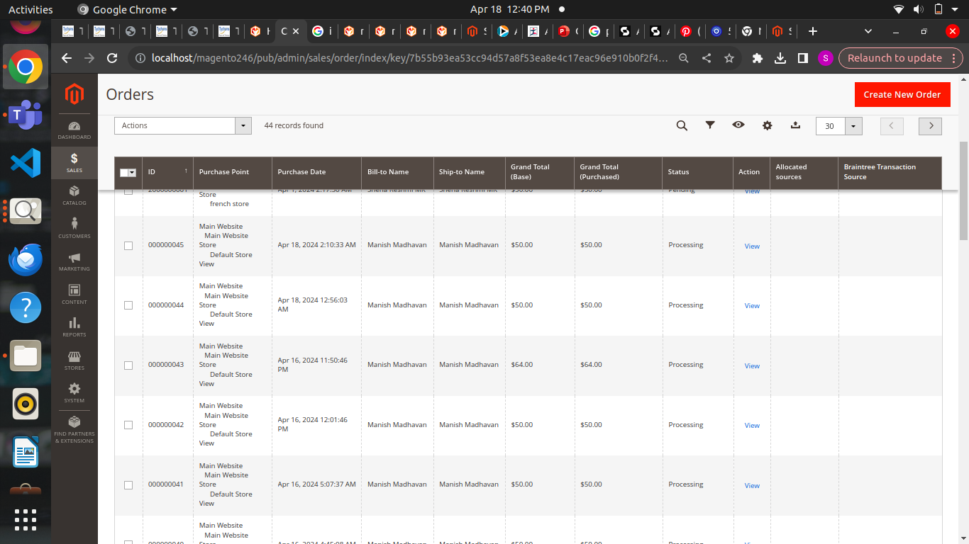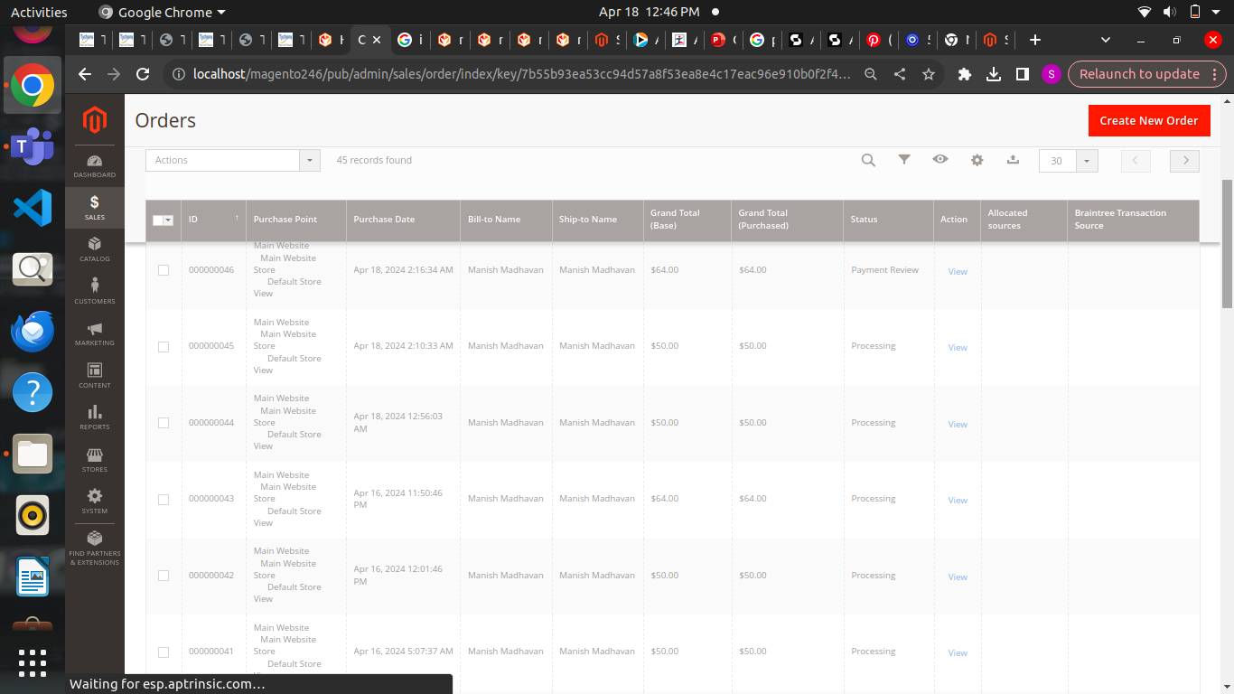

Task 26:

In custom tab created a tab order details and displayed order id, product name, sku and price

Solution followed:

* the View class for the Tychons_AdminCustomerTabPayment module in Magento 2, which creates a custom admin tab displaying order details for a specific customer, leveraging various Magento APIs to retrieve customer orders and their items.
* This XML code configures a layout in Magento 2 to add a custom tab labeled "My Custom New Tab" to the customer edit form in the admin panel, using the Tychons\AdminCustomerTabPayment\Block\Adminhtml\CustomerEdit\Tab\View block class, with a specified sort order of 100.
* This PHP code retrieves a list of customer orders and displays them in an HTML table format, showing the order ID, product name, SKU, and price, or a message indicating that no orders are found if the customer has no orders.

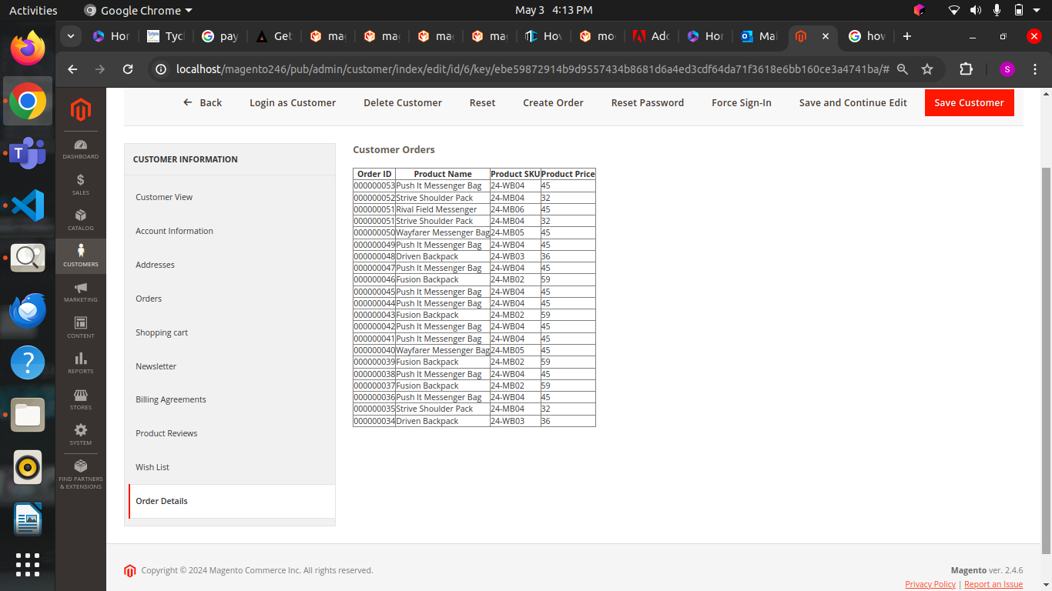

Task 27:

Fetched specific custom like customer 6 and fetched their invoice details and displayed the invoice details and created new tab in customer details and displayed the invoice details in the table format

Solution followed

* admin block that retrieves and displays invoice details for a specific customer, including the invoice number, amount, date, and customer information, while implementing the necessary methods to manage the visibility and labeling of a tab in the customer edit interface.
* This XML layout configuration file defines a new block for a custom tab labeled "My Custom New Tab" in the customer edit form within the Magento 2 admin panel, setting its sort order to 100.
* This code snippet displays the invoice details for a customer, showing an error message if no invoices are found, and presenting a table with the invoice number, total amount, customer email, customer name, and invoice date if invoices exist.

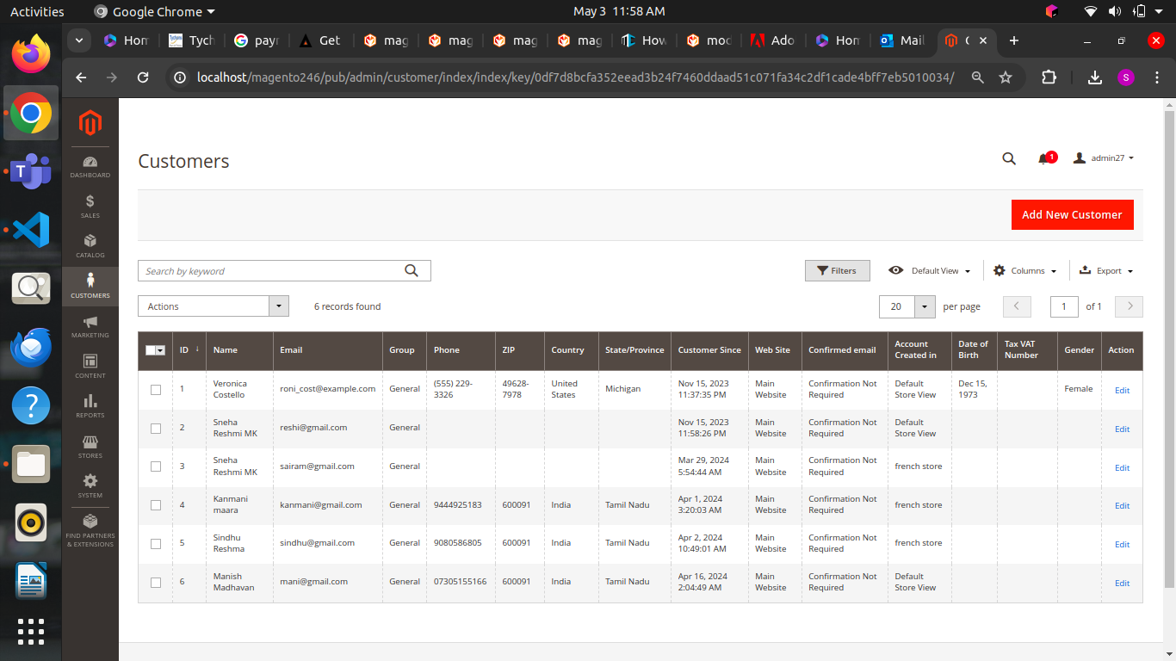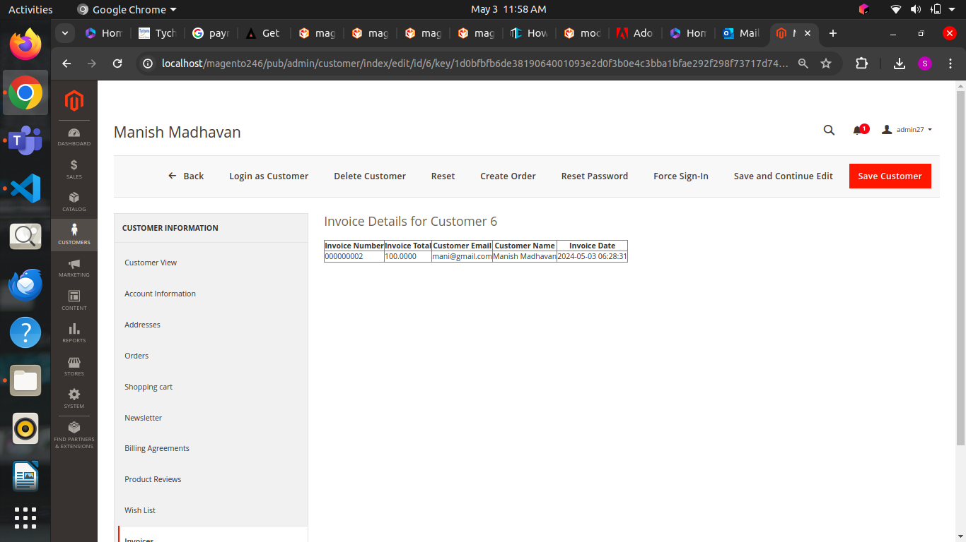

Task 28:

Displayed customer order id , product details and credit card details but credit cart details are empty

Displayed in customer index edit page

Solution followed

* displays a table of customer orders, including product details and payment information, or a message indicating no orders are found if there are none.
* block class that retrieves and displays customer order details, including product and payment information, in a custom admin tab for customer management.
* displays a table of a customer's orders, including product details and payment information, or shows a message indicating that no orders are found if the customer has none.

Task 29:

Overview of Magento Data Migration Tool data transfer from magento 1 and magento 2

In detailed way document task

Solution followed:

* The Magento Data Migration Tool is a command-line interface that facilitates the transfer of data from Magento 1 to Magento 2, ensuring data consistency, managing migration progress, and utilizing mapping files to adapt to differences in database structures.

Task 30:

Unit Testing document

Solution followed:

* Unit testing in Magento 2 is essential for validating individual code components to ensure they function as intended, while troubleshooting involves resolving OpenSearch connectivity errors, ensuring a seamless integration of search functionalities.

Task 31

Done unit testing for all the custom task which are completed

Solution followed

* Created test folder and mentioned to test the methods ad functions mentioned in the code
* Run unit testing command
* Tested the functions

Task 32

Page builder documentation and simple magento known issues document

Solution followed

* Page Builder in Magento 2 is a user-friendly, drag-and-drop content creation tool that enables developers to customize and extend content types while allowing non-developers to easily create and manage pages and blocks without coding.
* This document outlines common issues in Magento 2, including admin password resets, flat catalog settings, developer mode activation, user role assignment, JavaScript and CSS optimization, and cache management, along with their respective solutions.

Task 33

Check github open known issues

Solution followed

* The document outlines known issues and solutions in Magento related to admin filter functionality, collection overrides, multi-store configurations, and data migration errors, especially focusing on compatibility challenges when upgrading to PHP 8.2.

Task 34

In checkout page added new shipping method section and displayed shipping method which is selected from the backend

Solution Followed

* XML code configures a Magento checkout page layout to include a new checkout step called "mynewstep," which uses a custom JavaScript component located at Tychons_Custom/js/view/checkout/my-step-view, positioned at sort order 15.
* This JavaScript code defines a Magento 2 UI component that registers a new checkout step called "mynewstep" with a visibility observable and navigation functionality, using a custom template located at Tychons_Custom/checkout/mystep.
* HTML code creates a list item for a checkout step named "mynewstep," containing a form with radio buttons for selecting shipping methods (Flat Rate, Free Shipping, Table Rate) and a submit button labeled "Next," which is bound to a function that navigates to the next step in the checkout process.

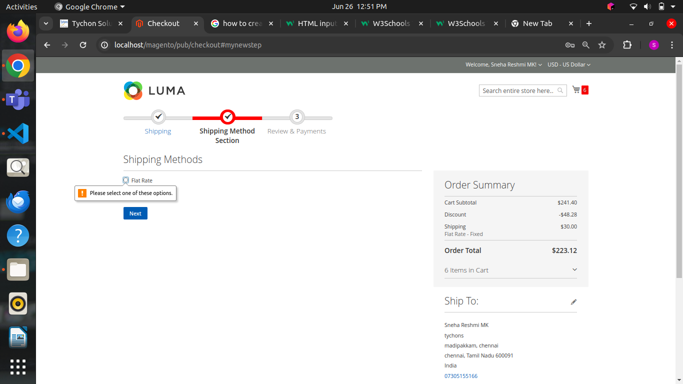

Task 35:

One page checkout document task

Solution Followed

* The document compares Magento's built-in one-step checkout feature with third-party extensions, outlining the advantages and disadvantages of each in terms of cost, customization, performance, integration, support, user experience, and additional features, highlighting that third-party solutions offer more extensive capabilities but come with added costs and complexity.

Task 36:

One page checkout extension task

Solution Followed:

* Checkout block class in Magento 2 manages customer quotes, shipping and payment methods, addresses, and related functionalities to facilitate the one-page checkout process.
* This LoginStatus block class in Magento 2 uses the customer session to check if a customer is logged in, allowing the display of different content based on their login status during the one-page checkout process.
* Fetch.php controller retrieves a customer's or guest's address based on their login status, fetching it from either the customer address repository or the sales order address table, and returns the address as a JSON response.
* Save controller saves a logged-in customer's address using the submitted data and returns a success or error message in JSON format.
* Order controller handles placing an order by processing the provided shipping address, payment method, and shipping method, then saves the order and returns a success or failure response in JSON format.
* AddAddress controller allows guest users to save a shipping address with region details and returns a JSON response indicating success or failure.
* Guest Order controller processes guest orders by setting address, shipping, and payment methods, placing the order, and returning a success or failure response in JSON format.
* Di.xml file registers a plugin for the CartManagementInterface, corrects the preference for AddressRepositoryInterface, and defines an argument for the Address Fetch controller in the Magento 2 module.
* helper class retrieves and returns a list of active shipping methods with their respective codes and titles from the Magento configuration.
* plugin file redirects the user to the checkout success page after an order is successfully placed in Magento.
* View folder mentioned checkout_index_index.xml file layout and in template file added details to display payment methods,shipping methods and shipping address for both logged in and logged out customer
* Used CSS file for frontend design

Output:

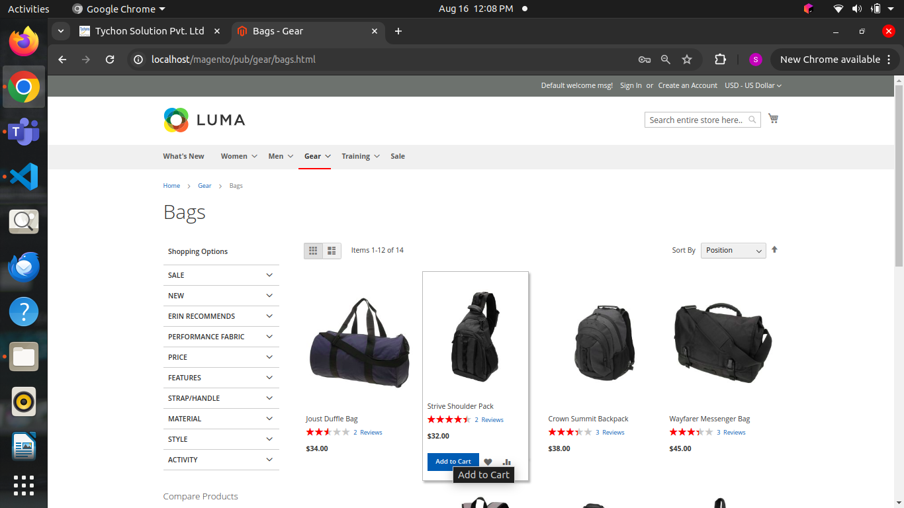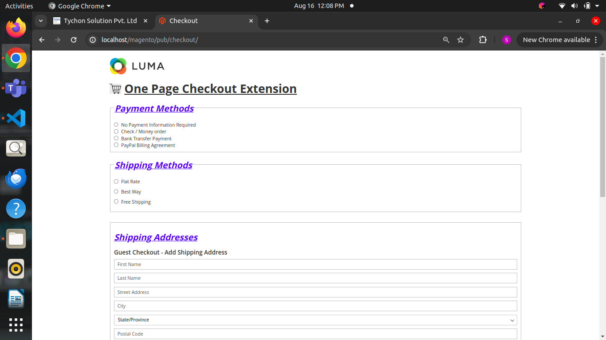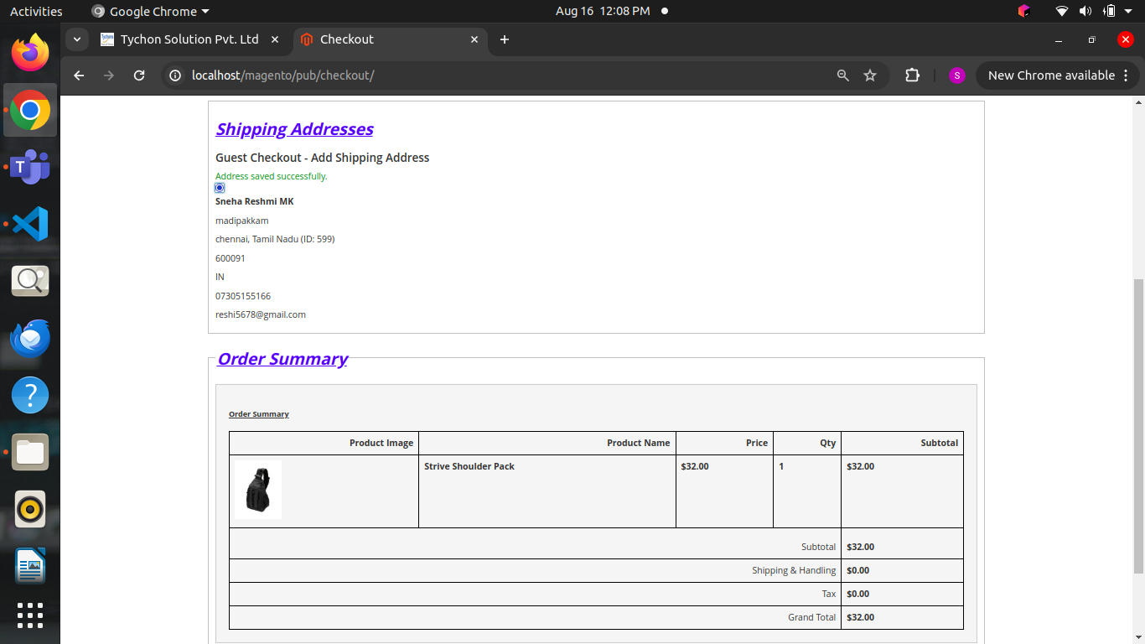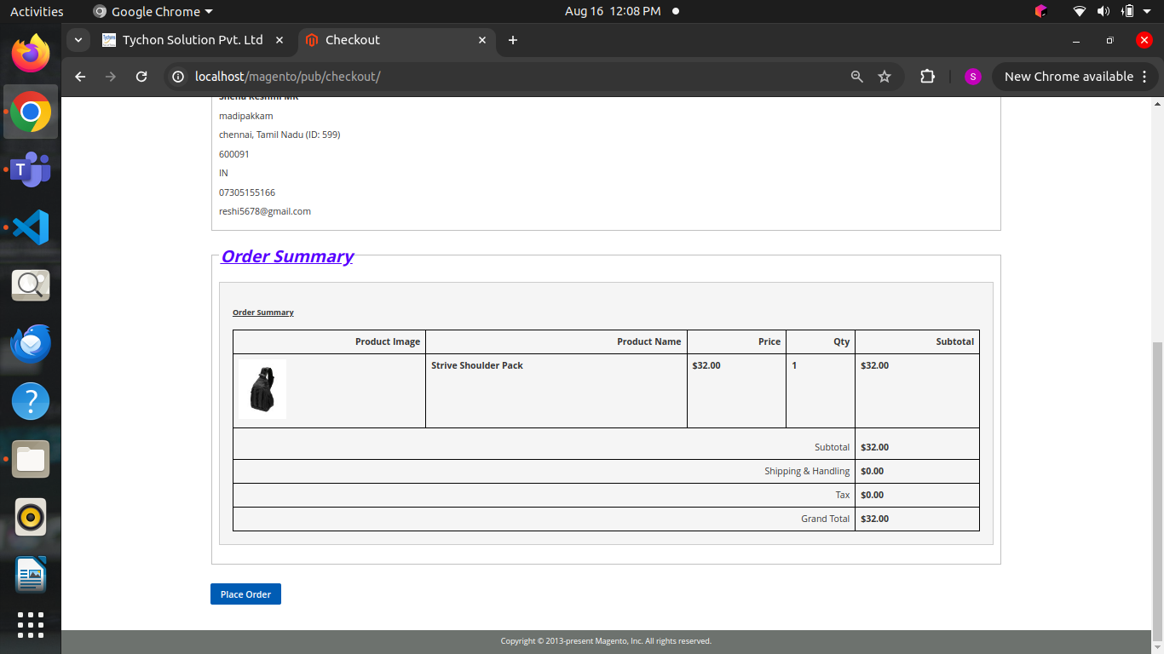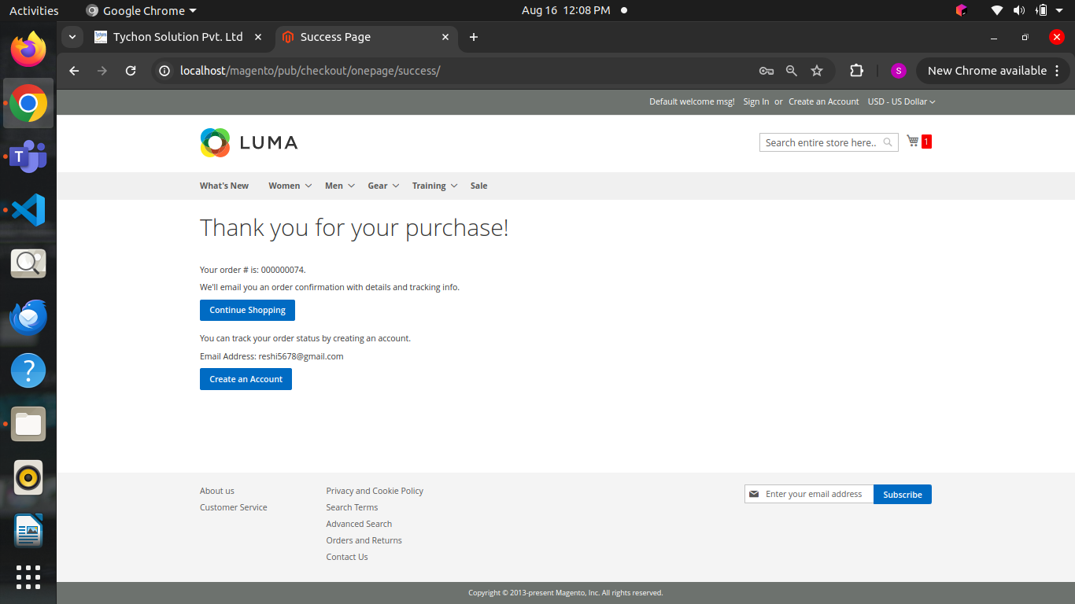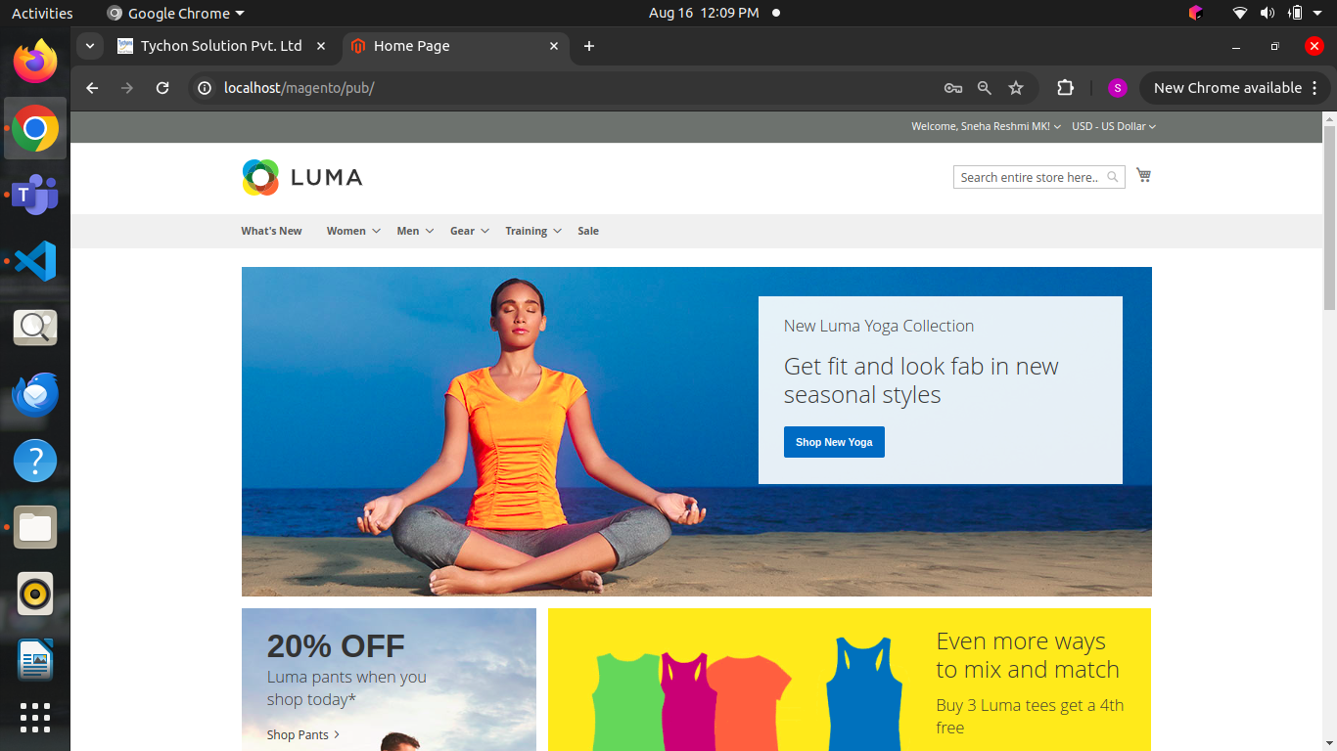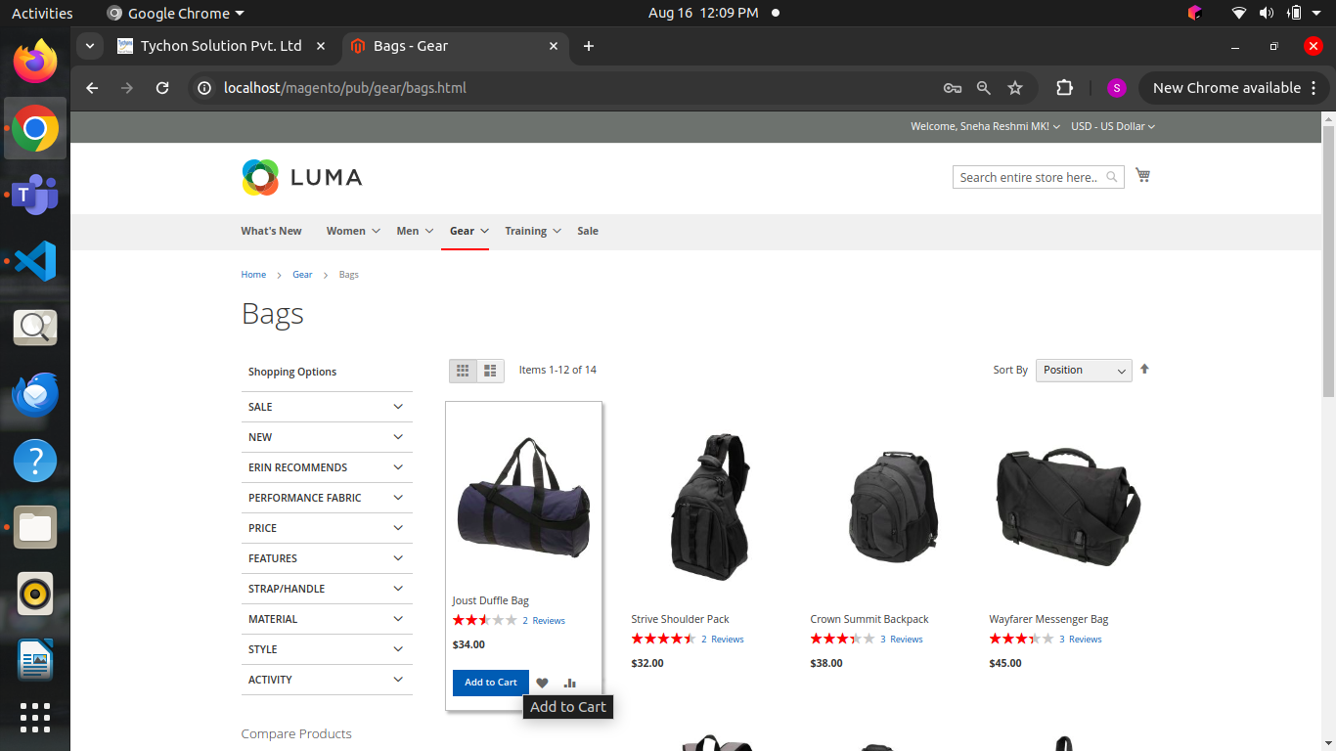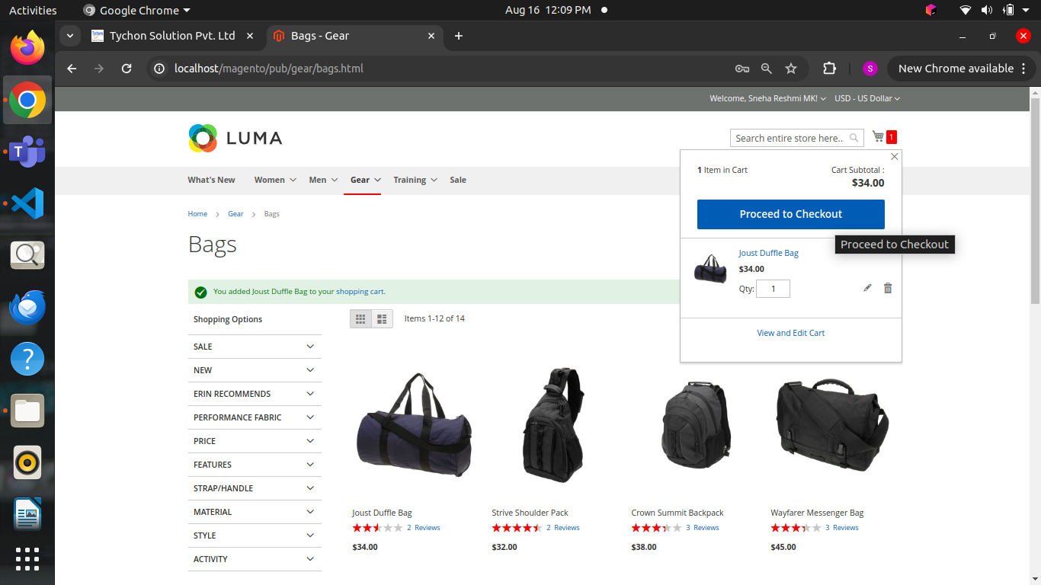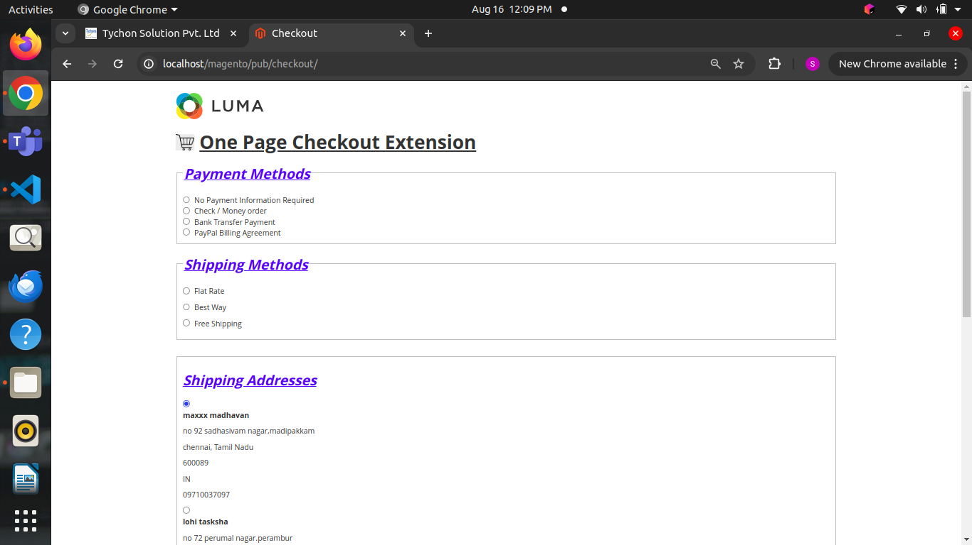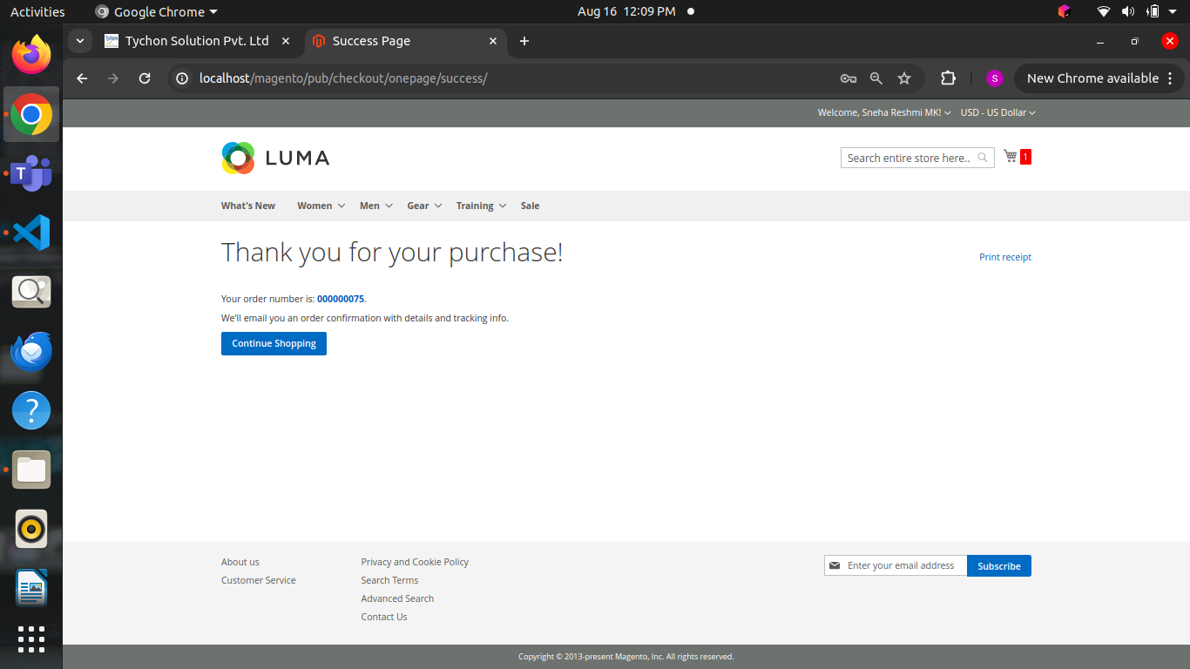

Task 37:

Checkout success page extension

Solution followed

* Success block class retrieves and formats the details of the last order, including payment and shipping information, and item details with images, to be displayed on the order success page in Magento.
* Events.xml sets up an observer that triggers the SalesOrderPlaceAfter class when a new order is successfully placed in Magento.
* Observer code defines an observer that retrieves and displays the payment method and shipping details of an order after it is placed, using Magento's event system.
* Used view layout and template file in the template file displayed all the details of payment method, shipping method, shipping address and order details in the success page

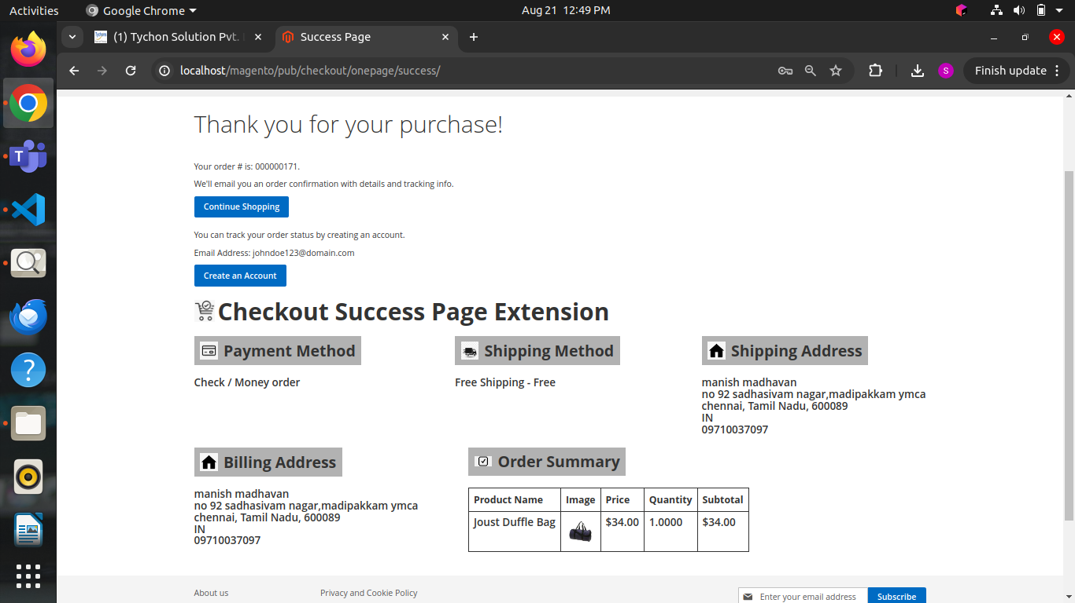

Task 38

Issues faced in the one-page checkout extension task

Solution Followed:

* This document explains the issues faced while developing a one-page checkout extension in Magento 2 and provides corresponding solutions for each problem encountered during the implementation process.

Task 39

Magento open known issues document  
  
Solution Followed:

* This document explains magento issues, their error messages, and solutions for fixing them, including problems with admin access, 404 errors, image display, memory limits, compilation errors, cache issues, performance slowdowns, module conflicts, email sending failures, and cache refreshing problems.

Task 40

Product export task

Solution Followed:

* PHP code defines a Magento 2 controller that exports a list of products, including their ID, SKU, name, price, and quantity, into a CSV file for download.
* UI component for displaying a product listing grid with features like filtering, mass actions, pagination, and export options for product data.

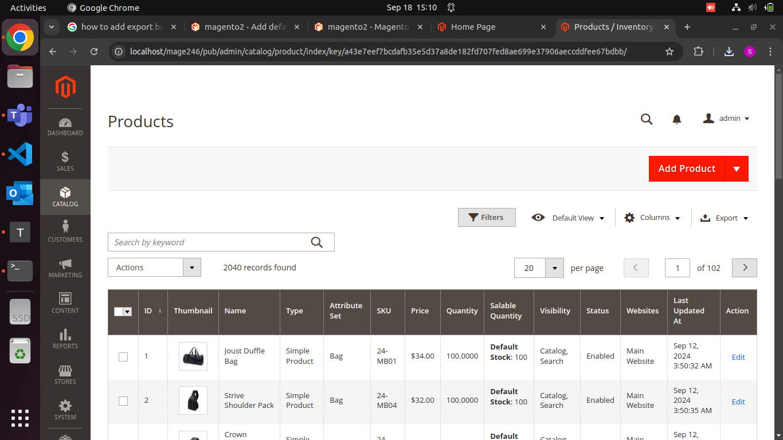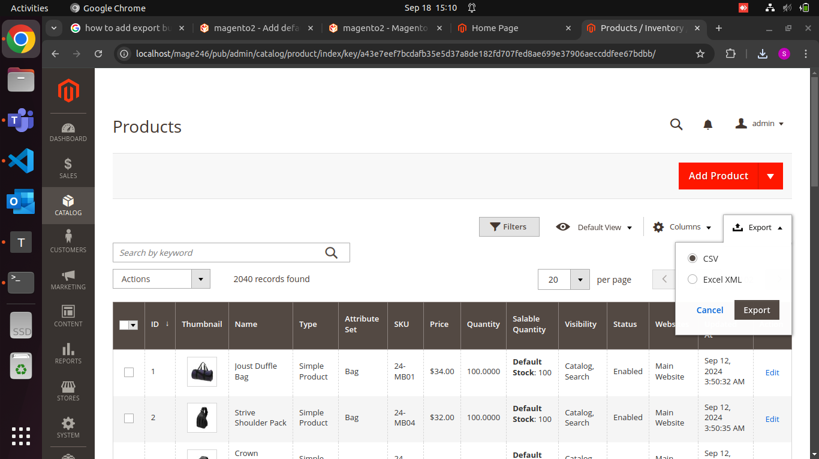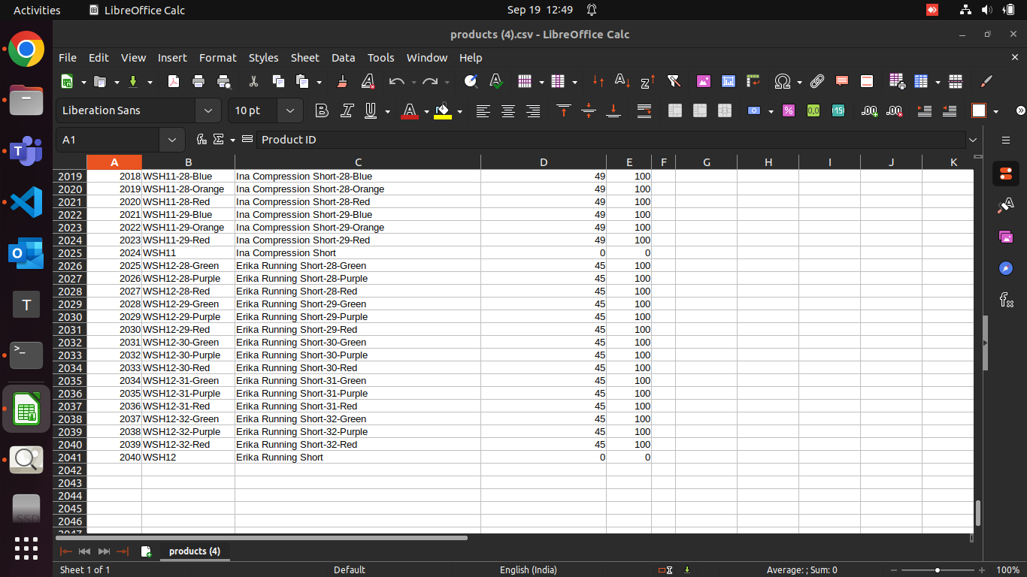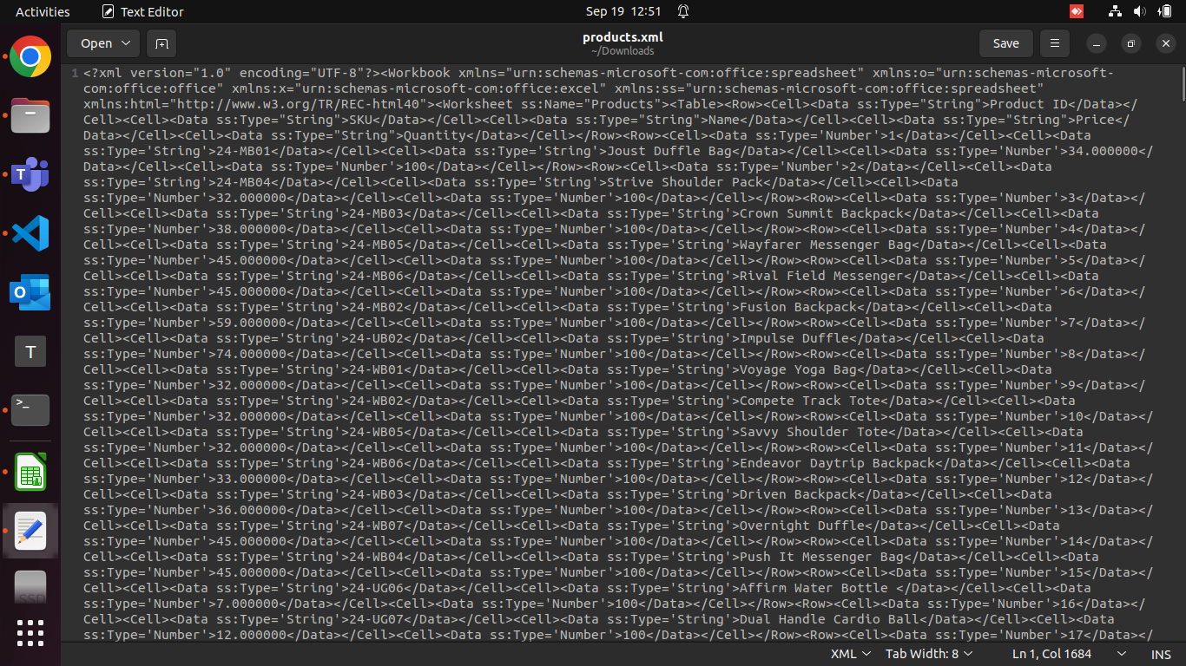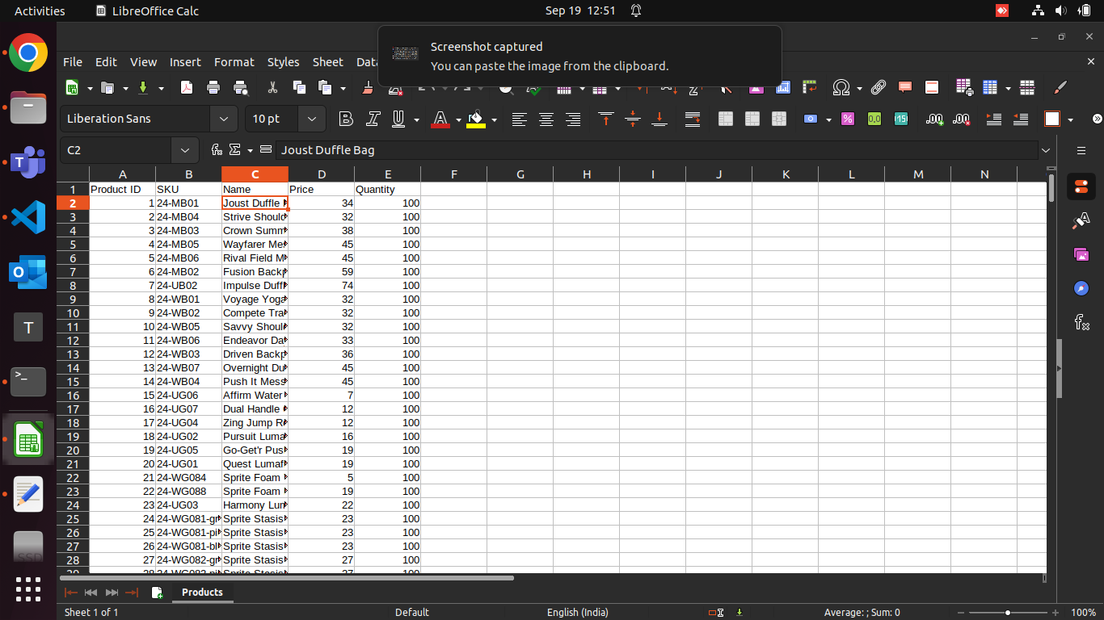

Task 41:

Admin grid task Next custom task, Get the exception log from var folder and display in the admin one by one Create the custom grid s.no date description. filter by date only.

Solution Followed:

* ViewDetails class in a Magento 2 module that retrieves and parses details from the Magento exception log file based on a provided serial number.
* CustomDataProvider class in a Magento 2 module that creates and configures a custom admin grid page with a specific title and breadcrumbs.
* GridToCsv class in a Magento 2 module that exports data retrieved from a custom data provider into a CSV file and prompts the user to download it.
* Edit class in a Magento 2 module that loads an entity for editing and prepares the edit form on a new page.
* Custom class that reads and processes entries from the Magento exception log, creates a data collection of the log entries, and provides methods to retrieve this data.
* Action class that prepares action links (like "View") for items in a UI grid column by generating URLs based on their unique identifier (s_no).
* sets up a Magento UI grid with a data source, listing toolbar for filters and pagination, columns for displaying data (including actions), and export options for CSV and XML formats.



Task 42:

Magento open known issues

Solution Followed:

* Explained 5 types of issues oauth and some more issues faced referred from the github

Task 43

Magento releases and php compatibility and deprecated functions

Solution Followed:

* In this document mentioned magento releases and php compatibility and deprecated functions

Task 44

Corrected admin grid with magento coding standard

Task 45

Document the all the custom task details   
  
document name: Magento Overall task document